Instructions for extended abstracts submission

Template

Theoretical and experimental results in ultrafast dynamics and ultrafast bandgap photonics
A. Penguin¹, P. Bear²
¹ South Pole University, 80539 Amazon, Antarctica
² The University of North Pole, 78464 Checkers, Arctic

The template is designed for speakers of all invited talks at X Ultrafast Dynamics and Ultrafast Bandgap Photonics Symposium to help them format their extended abstracts that will be published in the Abstract Proceedings of the Symposium.
The Symposium venue will be the Aldemar Knossos Royal Hotel- all inclusive 5-star hotel, resort and convention center in Hersonissos, Crete (June 17-22, 2024). It is hosted by the University of Crete and the Foundation for Research and Technology-Hellas (FORTH), Greece, while all local logistics are provided by MITOS PCO.
Replacing the template's title, list of authors, author's affiliation, text, figures, figure's captures, and the reference list with actual text and pictures, the template helps both authors and organizers.
The Symposium organizers plan to print a color Abstract Proceedings booklet that will include all invited talks in line with the IX the Ultrafast Dynamics and Ultrafast Bandgap Photonics Symposium that took place in June 2022 (Fig. 1)Abstract Proceedings were printed and delivered to all speakers and guests of the Symposium [1, 2].
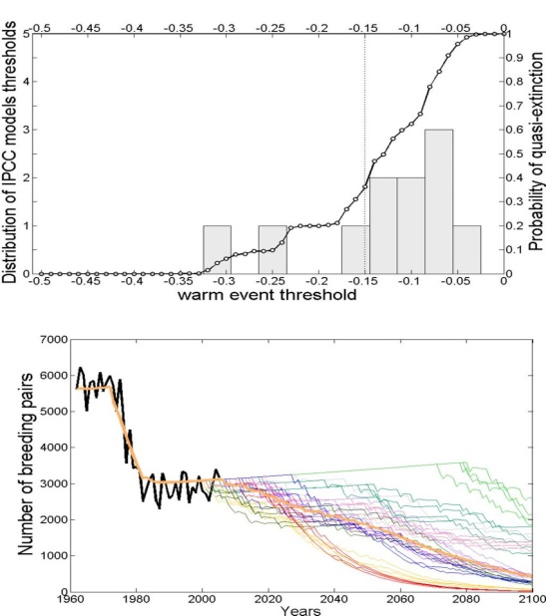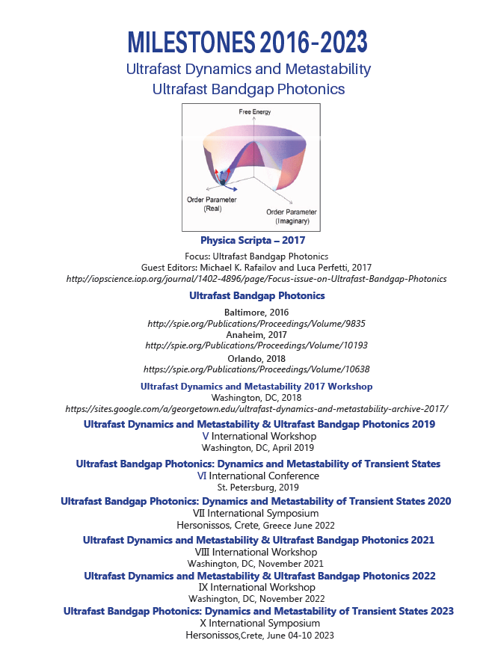

Fig. 1. Left :Antarctic penguin extinction rate [1]: Left: a- temperature dependence; b-year to year.
Right: back cover of Ultrafast Dynamics and Ultrafast Bandgap Photonics Symposium abstract proceedings.

The extended abstract length should be from 1 full page of A4 format to 4 full pages of A4 format, including figures, figure's captures and reference list. Symposium Committee recommends that an extended abstract will adjourn with few lines sentences where the idea, the concept or future development is listed resuming the text. Reference includes names of all authors, full name of a journal or publications - Proceedings of IEEE, etc., first page as is in the database and year of publications in breaks. If the abstract content scientific is not published yet, then please list where it will be published, where it will be sent, and the year. In case this info is not available - just put (to be submitted) and a year.
Acknowledgments should be listed after References* in the same font as the references in the list.

References
[1] A. Penguin, A. Raccoon, P. Bear, Physical Review B 152, 184351, (2070).
[2]
[3]
* Acknowledgement(s) : authors (…) acknowledge support from NSF, (grant…).

